# Appendix H

# Reference frame offsets for ground truth markers at Jammertest 2025

## Introduction

The Norwegian Public Roads Administration will establish ground truth markers at Jammertest, ref. Appendix A of the Test Catalogue. Ground truth markers are well marked points on ground (or tied to ground), for which accurate coordinates have been computed. We provide this document to inform the Jammertest participants about the differences between the most used geodetic reference frames in Norway. The document also provides the necessary information to perform simple horizontal transformations between these reference frames, and some information about the differences between ellipsoidal heights (“GNSS heights”) and physical heights (“heights above mean sea level”) in the test areas.

## Reference systems and reference frames

The terms “reference system” and “reference frame” are often used somewhat interchangeably, which might be confusing. The difference between these terms is that a reference **system** is the theoretical definition of a coordinate system and its relation to a geophysical or geometrical model of the earth, whereas a reference **frame** consists of a set of physical points with computed coordinates that indirectly defines the “invisible” reference system. Therefore, a reference frame is called a realization of a reference system. For example, ETRF89 (European Terrestrial Reference Frame 1989) is a realization of ETRS89 (European Terrestrial Reference System 1989). In practice, each European country has its own realization of ETRS89, and they may differ by a few centimeters with respect to each other.

## EUREF89

EUREF89 is a Norwegian realization of ETRS89 and is the official reference frame for Norwegian maps. EUREF89 is considered a static 3D reference frame with the fixed reference epoch 1989 Jan. 1st. The term “static” means that the reference frame is tied to the stable part of the Eurasian tectonic plate, so that the horizontal coordinates of a point do not change with time (as a general rule) even though the Eurasian continent is moving. This property differs from global reference frames, ref. section 5.

The ground truth coordinates for the ground truth markers at Jammertest (the surveyed points in Appendix A of the Test Catalogue) are given in EUREF89.

## Some coordinate forms in a reference frame

Coordinates for a point P at the surface of the Earth can be given in various forms, e.g.

* Cartesian coordinates X, Y, Z (Figure 1)
* Ellipsoidal coordinates ϕ (latitude), λ (longitude), h (height above ellipsoid) (Figure 1)
* In a map projection, e.g. UTM33 as North, East and height (above ellipsoid) (Figure 2)

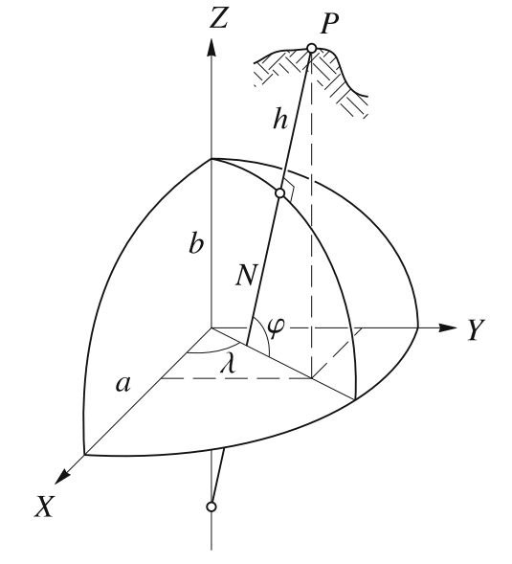

Figure 1: From [1] GNSS – Global Navigation Satellite Systems

For equations to convert between the coordinate forms, see e.g. [1].

The Norwegian Mapping Authority (NMA) operates a nationwide Network RTK service which is named CPOS. Coordinates for the permanent GNSS stations used in CPOS refer to EUREF89.

**Note:** Coordinates computed by measurements done by a GNSS receiver that is using correction data from CPOS, will refer to EUREF89. More detailed information in the NMA report [3] (in Norwegian language only)*.*

If we look at Figure 2, we observe that we can pick a representation point with convenient round numbers in EUREF89 UTM zone 33, close to the Jammertest test areas:

* The UTM33 coordinates are North N=7,690,000 and East E=540,000.
* The ellipsoidal coordinates are Latitude = 69.316631093° and Longitude = 16.014796031°.

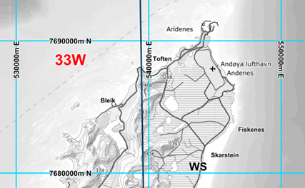

Figure 2: The UTM33 grid for EUREF89 at Andøya

## Global 4D reference frames

In a global reference frame, the coordinates of a point change as a function of time, as the continents move mainly due to the plate tectonics. To achieve unambiguity in such a frame, the time (epoch) to which the coordinates refer must be specified. ITRF2014, IGS14 and WGS84 are all global reference frames and very similar to each other.

**Note**: Coordinates computed by a GPS receiver without using any external corrections, will refer to WGS84, current epoch of time (the moment of measurement).

## Reference frame differences at Andøya, September 2025

A transformation of the representation point mentioned in section 4 (N=7,690,000 and E=540,000) with the NMA software SkTrans from EUREF89 to ITRF2014 (very similar to WGS84) epoch 2025.7 (2025 Sep. 12th) gives:

* UTM33: N = 7,690,000.6522 and E = 540,000.4716
* Ellipsoidal coordinates: Lat = 69.316636870° and Long = 16.014808267°.

Hence, approximate transformation equations from EUREF89 epoch 1989.00 to ITRF2014≈WGS84 epoch 2025.7 for all points in the test areas at Andøya around 2025 September 12th become:

${N }_{WGS84 epoch2025.7}=N_{EUREF89UTM{33}_{epoch1989.0}}+∆N$ where ∆N = 0.652 m ${E }_{WGS84 epoch2025.7}=E_{EUREF89UTM{33}_{epoch1989.0}}+∆E$  
 where ∆E = 0.472 m

${φ }_{WGS84 epoch2025.7}=φ_{EUREF89UTM{33}_{epoch1989.0}}+∆Lat$ where $∆Lat$ = 0.000005777° ${λ }_{WGS84 epoch2025.7}=λ_{EUREF89UTM{33}_{epoch1989.0}}+∆Long$ where $∆Long$ = 0.000012236°

Seven significant decimal digits for latitude and longitude will ensure cm-precision.

Annual drift parameters are:

* UTM33: ∆N=0.0165 m/y and ∆E=0.0136 m/y
* Ellipsoidal coordinates: *ΔLat=0.000000146°/y and ΔLong=0.000000352*°/y

## Vertical coordinates (heights)

Vertical coordinates (heights) computed by GNSS receivers refer to a rotational ellipsoid which is a simplified model of the earth. These heights are called ellipsoidal heights, or heights above ellipsoid. On the other hand, the mean sea level roughly aligns to the geoid, which is an equipotential surface in the earth’s gravity field (ref. Figure 3). To translate ellipsoidal heights into physical heights (heights above mean sea level), a geoid model must be applied. Geoid models originate from gravimetric measurements. If high accuracy of the physical heights is required, height reference models (which are geoid models adjusted by a combination of GNSS measurements and levelling) must be used. Many GNSS receivers have built-in geoid models or height reference models.

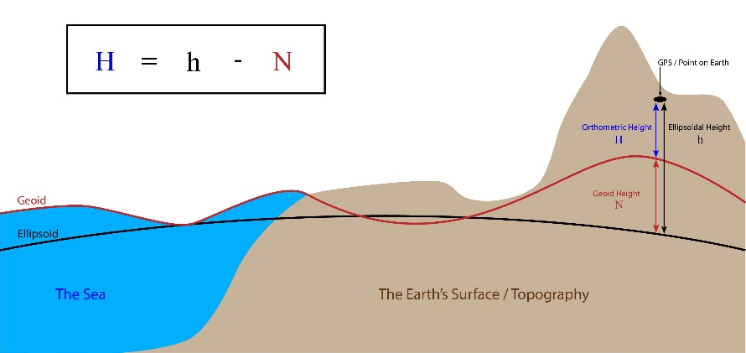

Figure 3: Ellipsoid and geoid. Credit: <https://support.virtual-surveyor.com/>

The differences [ellipsoidal heights minus physical heights] (N in Figure 3) in the Jammertest areas vary from about +35.6 meters at Andenes to about +36.2 meters at Nordmela just south of test area 3.

## References

[1] GNSS – Global Navigation Satellite Systems, Hofmann-Wellenhof, Lichtenegger and Wasle.  
ISBN 978-3-211-73012-6 SpringerWienNewYork 2008

[2] [Geodetisk grunnlag](https://sosi.geonorge.no/standarder/Geodetisk_grunnlag_-_koordinatbaserte_referansesystemer_og_kvalitetssikring_av_grunnlagspunkt/1.0/) [Geodetic datum] (in Norwegian language only). Norwegian official standard.

[3] [Referanserammer og transformasjoner](https://www.kartverket.no/globalassets/forskning-og-utvikling/rapporter/referanserammer-og-transformasjoner-2023.pdf) [Reference frames and transformations](in Norwegian language only).  
NMA report: 19-04811-18, ISBN: 978-82-7945-476-2

|  |  |
| --- | --- |
|  | Norwegian Mapping Authority |